West Suburban Bulls EAP for games at Chicago Blaze rugby Complex

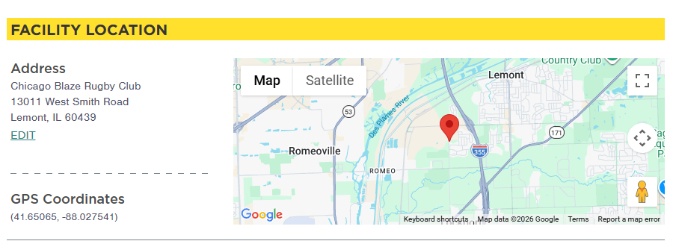
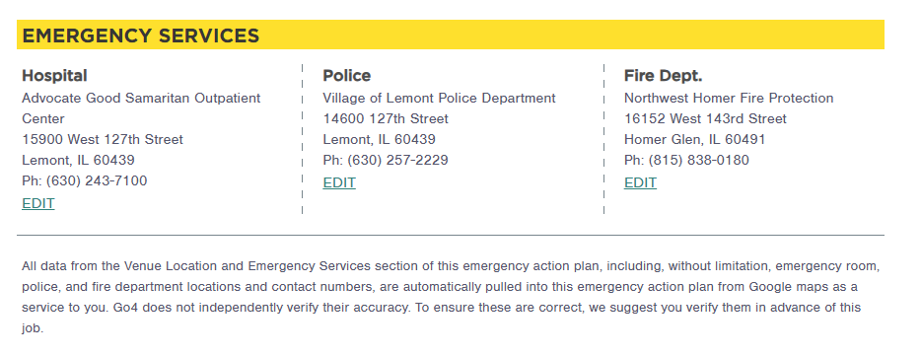

Bulls Contact Person John Weyer (708)275-0821 wsbrfcjohn@gmail.com

